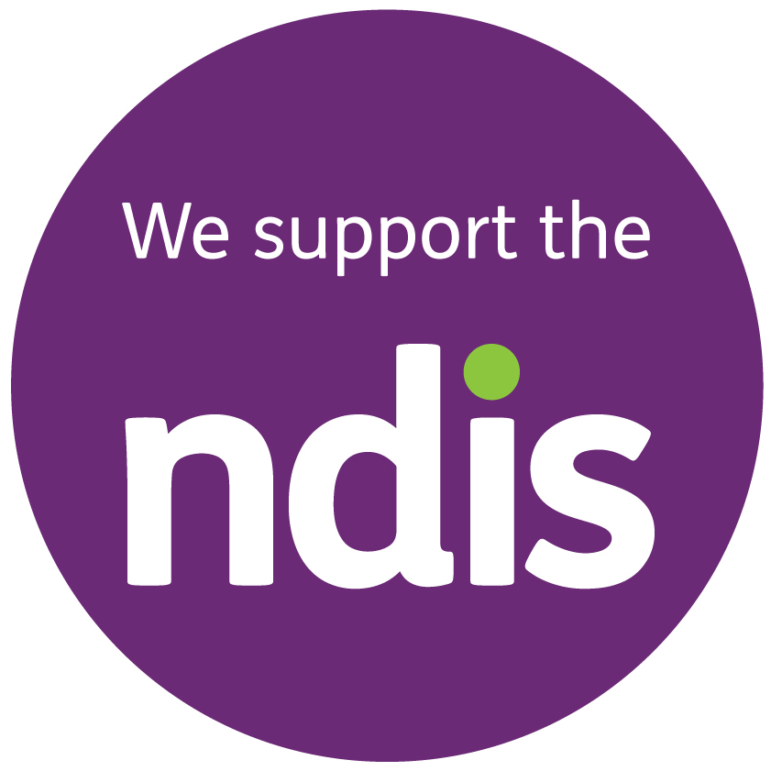

|  |  |  |  |  |  |  |  |  |  |  |  |  |  |  |  |  |  |  |  |  |  |  |  |  |  |  |  |  |  |  |
| --- | --- | --- | --- | --- | --- | --- | --- | --- | --- | --- | --- | --- | --- | --- | --- | --- | --- | --- | --- | --- | --- | --- | --- | --- | --- | --- | --- | --- | --- | --- |
| Soul Services WA were thrilled to have been part of your NDIS Support Coordination journey – while our journey with you has sadly come to an end, we would very much appreciate your feedback on your experience with Soul Services WA.   |  |  |  |  |  |  | | --- | --- | --- | --- | --- | --- | |  | Very Satisfied | Satisfied | Neutral | Unsatisfied | Very Satisfied | | How satisfied were you with our services? |  |  |  |  |  | | Did you feel we listened to your needs/requirement |  |  |  |  |  | | Did we respond to you in a timely manner | ☐ | ☐ |  |  |  | | Were we genuine and knowledgeable |  |  |  |  |  | |
| 1. Chat What did we do well? |
| 1. ChatWhat did we do not so well? |
| Chat3. Please provide any suggestions or comments on what we can improve our services? |
| 1. ChatWould you recommend our services to others?   Yes  No  Maybe |
| We would love to share some of your feedback on our website/brouchers – please tick if you are ok for this to occur: Yes  No  Maybe |

**We Value Your Feedback!!**

Please complete the following form to help up us improve our customer experience

Thank You – Your Feedback is invaluable to us!!